**WEEK-4**

**SPRING REST USING SPRING BOOT 3**

**1.Create a Spring Web Project using Maven**   
  
Follow steps below to create a project:

1. Go to <https://start.spring.io/>
2. Change Group as “com.cognizant”
3. Change Artifact Id as “spring-learn”
4. Select Spring Boot DevTools and Spring Web
5. Create and download the project as zip
6. Extract the zip in root folder to Eclipse Workspace
7. Build the project using ‘mvn clean package -Dhttp.proxyHost=proxy.cognizant.com -Dhttp.proxyPort=6050 -Dhttps.proxyHost=proxy.cognizant.com -Dhttps.proxyPort=6050 -Dhttp.proxyUser=123456’ command in command line
8. Import the project in Eclipse "File > Import > Maven > Existing Maven Projects > Click Browse and select extracted folder > Finish"
9. Include logs to verify if main() method of SpringLearnApplication.
10. Run the SpringLearnApplication class.  
    SME to walk through the following aspects related to the project created:
11. src/main/java - Folder with application code
12. src/main/resources - Folder for application configuration
13. src/test/java - Folder with code for testing the application
14. SpringLearnApplication.java - Walkthrough the main() method.
15. Purpose of @SpringBootApplication annotation
16. pom.xml
    1. Walkthrough all the configuration defined in XML file
    2. Open 'Dependency Hierarchy' and show the dependency tree.

**CODE:**

package com.cognizant.spring_learn;

import org.slf4j.Logger;

import org.slf4j.LoggerFactory;

import org.springframework.boot.SpringApplication;

import org.springframework.boot.autoconfigure.SpringBootApplication;

@SpringBootApplication

public class SpringLearnApplication {

private static final Logger LOGGER = LoggerFactory.getLogger(SpringLearnApplication.class);

public static void main(String[] args) {

LOGGER.info("START");

SpringApplication.run(SpringLearnApplication.class, args);

LOGGER.info("END");

}

}

**OUTPUT**

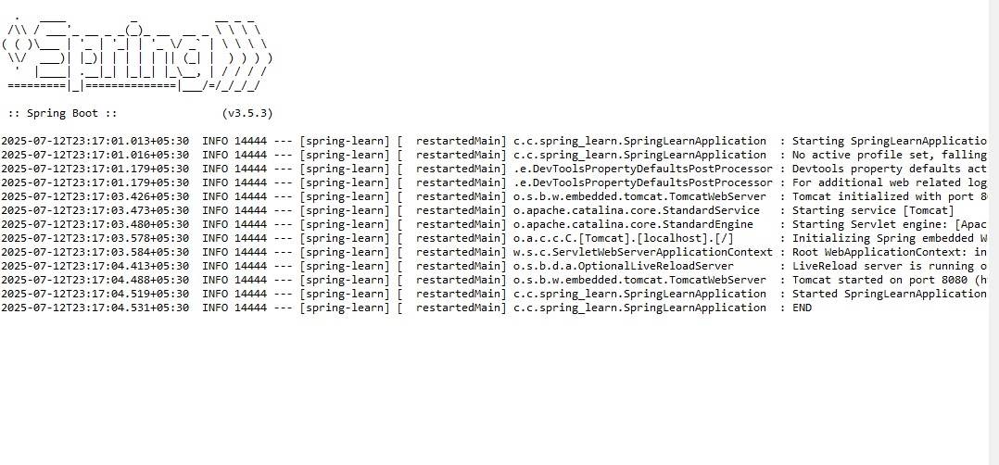

**2.Spring Core – Load Country from Spring Configuration XML**   
  
An airlines website is going to support booking on four countries. There will be a drop down on the home page of this website to select the respective country. It is also important to store the two-character ISO code of each country. 

|  |  |
| --- | --- |
| **Code** | **Name** |
| US | United States |
| DE | Germany |
| IN | India |
| JP | Japan |

Above data has to be stored in spring configuration file. Write a program to read this configuration file and display the details.  
  
Steps to implement

* Pick any one of your choice country to configure in Spring XML configuration named country.xml.
* Create a bean tag in spring configuration for country and set the property and values

    <bean id="country" class="com.cognizant.springlearn.Country">

        <property name="code" value="IN" />

        <property name="name" value="India" />

    </bean>

* Create Country class with following aspects:
  + Instance variables for code and name
  + Implement empty parameter constructor with inclusion of debug log within the constructor with log message as “Inside Country Constructor.”
  + Generate getters and setters with inclusion of debug with relevant message within each setter and getter method.
  + Generate toString() method
* Create a method displayCountry() in SpringLearnApplication.java, which will read the country bean from spring configuration file and display the country details. ClassPathXmlApplicationContext, ApplicationContext and context.getBean(“beanId”, Country.class). Refer sample code for displayCountry() method below.

ApplicationContext context = new ClassPathXmlApplicationContext("country.xml");

Country country = (Country) context.getBean("country", Country.class);

LOGGER.debug("Country : {}", country.toString());

* Invoke displayCountry() method in main() method of SpringLearnApplication.java.
* Execute main() method and check the logs to find out which constructors and methods were invoked.

SME to provide more detailing about the following aspects:

* bean tag, id attribute, class attribute, property tag, name attribute, value attribute
* ApplicationContext, ClassPathXmlApplicationContext
* What exactly happens when context.getBean() is invoked

**CODE:**

<?xml version="1.0" encoding="UTF-8"?>

<beans xmlns="http://www.springframework.org/schema/beans"

xmlns:xsi="http://www.w3.org/2001/XMLSchema-instance"

xsi:schemaLocation="http://www.springframework.org/schema/beans

https://www.springframework.org/schema/beans/spring-beans.xsd">

<bean id="dateFormat" class="java.text.SimpleDateFormat">

<constructor-arg value="dd/MM/yyyy" />

</bean>

</beans>

package com.cognizant.spring_learn;

import java.text.SimpleDateFormat;

import java.util.Date;

import org.slf4j.Logger;

import org.slf4j.LoggerFactory;

import org.springframework.context.ApplicationContext;

import org.springframework.context.support.ClassPathXmlApplicationContext;

import org.springframework.boot.SpringApplication;

import org.springframework.boot.autoconfigure.SpringBootApplication;

@SpringBootApplication

public class SpringLearnApplication {

private static final Logger LOGGER = LoggerFactory.getLogger(SpringLearnApplication.class);

public static void main(String[] args) {

LOGGER.info("START");

SpringApplication.run(SpringLearnApplication.class, args);

displayDate();

LOGGER.info("END");

}

public static void displayDate() {

ApplicationContext context = new ClassPathXmlApplicationContext("date-format.xml");

SimpleDateFormat format = context.getBean("dateFormat", SimpleDateFormat.class);

try {

Date date = format.parse("31/12/2018");

System.out.println("Parsed Date: " + date);

} catch (Exception e) {

System.err.println("Date parsing failed: " + e.getMessage());

}

}

}

**OUTPUT**

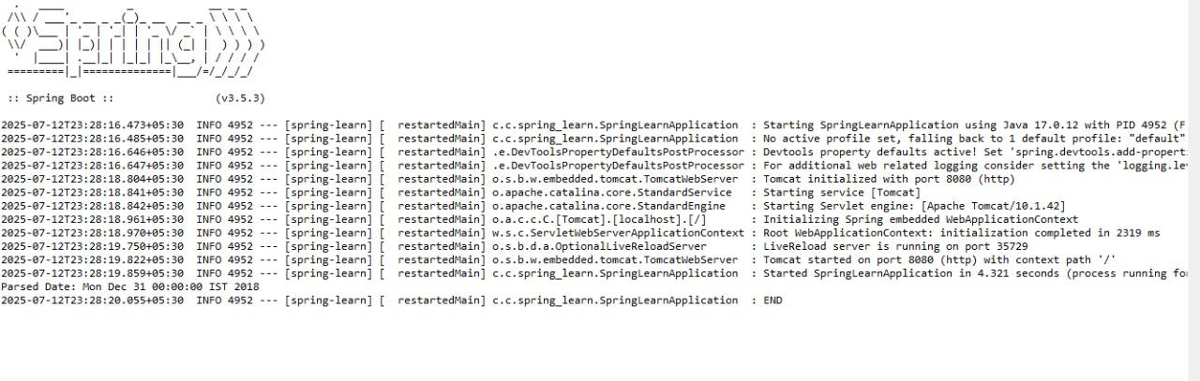

**3.Hello World RESTful Web Service**   
  
Write a REST service in the spring learn application created earlier, that returns the text "Hello World!!" using Spring Web Framework. Refer details below:  
  
**Method:** GET  
**URL:** /hello  
**Controller:** com.cognizant.spring-learn.controller.HelloController  
**Method Signature:** public String sayHello()  
**Method Implementation:** return hard coded string "Hello World!!"  
**Sample Request**: http://localhost:8083/hello  
**Sample Response:** Hello World!!   
  
**IMPORTANT NOTE**: Don't forget to include start and end log in the sayHello() method.  
  
Try the URL http://localhost:8083/hello in both chrome browser and postman.  
  
SME to explain the following aspects:

* In network tab of developer tools show the HTTP header details received
* In postman click on "Headers" tab to view the HTTP header details received

**REST - Country Web Service**   
Write a REST service that returns India country details in the earlier created spring learn application.  
**URL**: /country  
**Controller**: com.cognizant.spring-learn.controller.CountryController  
**Method Annotation**: @RequestMapping  
**Method Name**: getCountryIndia()  
**Method Implementation**: Load India bean from spring xml configuration and return  
**Sample Request**: http://localhost:8083/country  
**Sample Response**:

{

  "code": "IN",

  "name": "India"

}

SME to explain the following aspects:

* What happens in the controller method?
* How the bean is converted into JSON reponse?
* In network tab of developer tools show the HTTP header details received
* In postman click on "Headers" tab to view the HTTP header details received

**CODE:**

package com.cognizant.spring_learn;

import org.slf4j.Logger;

import org.slf4j.LoggerFactory;

import org.springframework.web.bind.annotation.GetMapping;

import org.springframework.web.bind.annotation.RestController;

@RestController

public class HelloController {

private static final Logger LOGGER = LoggerFactory.getLogger(HelloController.class);

@GetMapping("/hello")

public String sayHello() {

LOGGER.info("START sayHello()");

String message = "Hello World!!";

LOGGER.info("END sayHello()");

return message;

}

}

package com.cognizant.spring_learn;

import org.slf4j.Logger;

import org.slf4j.LoggerFactory;

import org.springframework.boot.SpringApplication;

import org.springframework.boot.autoconfigure.SpringBootApplication;

@SpringBootApplication

public class SpringLearnApplication {

private static final Logger LOGGER = LoggerFactory.getLogger(SpringLearnApplication.class);

public static void main(String[] args) {

LOGGER.info("START");

SpringApplication.run(SpringLearnApplication.class, args);

LOGGER.info("END"); }

}

**OUTPUT**

spring.application.name=spring-learn

server.port=8083

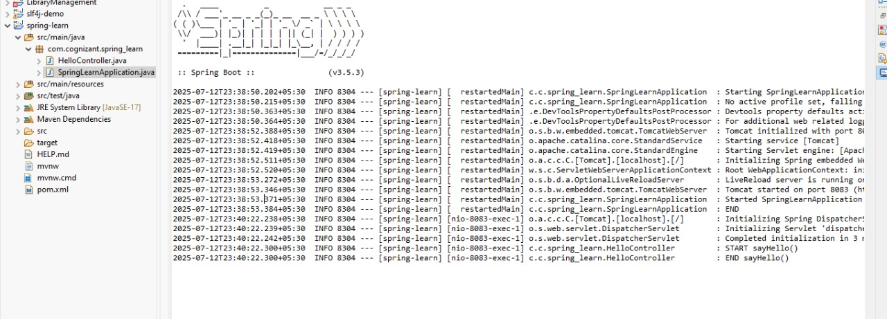

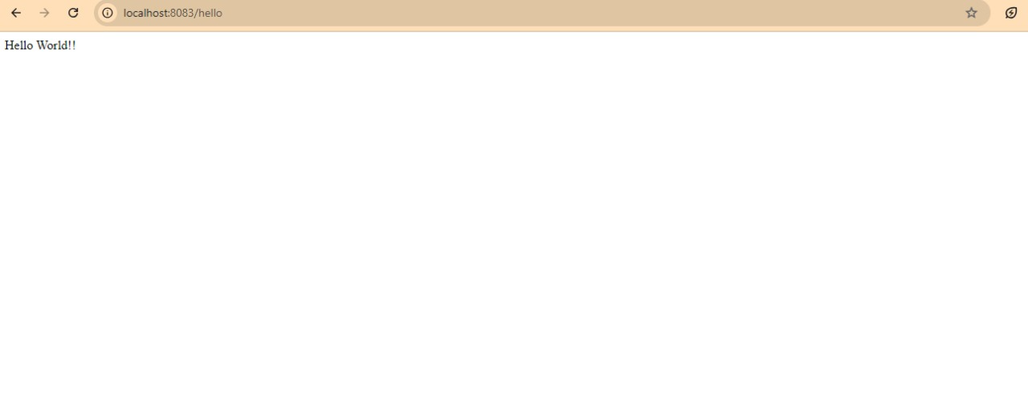

**4.REST country web service**

**CODE:**

**CountryController.java**

package com.cognizant.spring_learn.controller;

import com.cognizant.spring_learn.Country;

import org.slf4j.Logger;

import org.slf4j.LoggerFactory;

import org.springframework.context.ApplicationContext;

import org.springframework.context.support.ClassPathXmlApplicationContext;

import org.springframework.web.bind.annotation.RequestMapping;

import org.springframework.web.bind.annotation.RestController;

@RestController

public class CountryController {

private static final Logger *LOGGER* = LoggerFactory.*getLogger*(CountryController.class);

@RequestMapping("/country")

public Country getCountryIndia() {

*LOGGER*.info("START - getCountryIndia()");

ApplicationContext context = new ClassPathXmlApplicationContext("country.xml");

Country country = context.getBean("country", Country.class);

*LOGGER*.info("END - getCountryIndia()");

return country;

}

}

**COUNTRY.XML**

<?xml version="1.0" encoding="UTF-8"?>

<beans xmlns="http://www.springframework.org/schema/beans"

xmlns:xsi="http://www.w3.org/2001/XMLSchema-instance"

xsi:schemaLocation="

http://www.springframework.org/schema/beans

http://www.springframework.org/schema/beans/spring-beans.xsd">

<bean id="country" class="com.cognizant.spring_learn.Country">

<property name="code" value="IN"/>

<property name="name" value="India"/>

</bean>

</beans>

**COUNTRY.JAVA**

package com.cognizant.spring_learn;

import org.slf4j.Logger;

import org.slf4j.LoggerFactory;

public class Country {

private static final Logger *LOGGER* = LoggerFactory.*getLogger*(Country.class);

private String code;

private String name;

// Constructor

public Country() {

*LOGGER*.debug("Inside Country Constructor.");

}

// Getter and Setter for code

public String getCode() {

*LOGGER*.debug("Inside getCode()");

return code;

}

public void setCode(String code) {

*LOGGER*.debug("Inside setCode()");

this.code = code;

}

// Getter and Setter for name

public String getName() {

*LOGGER*.debug("Inside getName()");

return name;

}

public void setName(String name) {

*LOGGER*.debug("Inside setName()");

this.name = name;

}

// toString method

@Override

public String toString() {

return "Country [code=" + code + ", name=" + name + "]";

}

}

**APPLICATION.PROPERTIES**

spring.application.name=spring-learn

server.port=8084

logging.level.com.cognizant=DEBUG

logging.level.root=DEBUG

**SPRINGLEARNAPPLICATION.JAVA**

package com.cognizant.spring_learn;

import org.springframework.boot.SpringApplication;

import org.springframework.boot.autoconfigure.SpringBootApplication;

@SpringBootApplication

public class SpringLearnApplication {

public static void main(String[] args) {

SpringApplication.*run*(SpringLearnApplication.class, args);

}

}

**OUTPUT:**

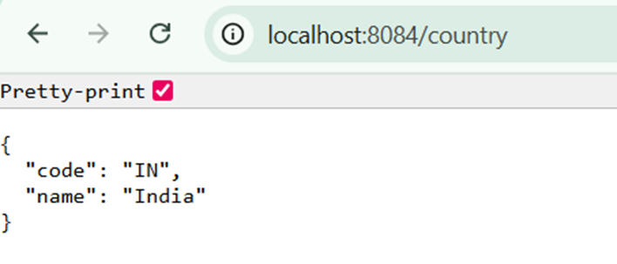

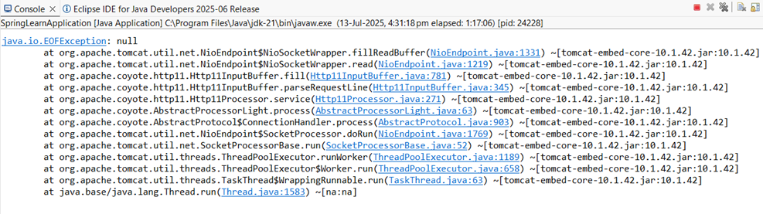

**5.REST – Country based on country code**

**CODE:**

**COUNTRY SERVICE.JAVA**

package com.cognizant.spring_learn.service;

import com.cognizant.spring_learn.Country;

import org.springframework.context.ApplicationContext;

import org.springframework.context.support.ClassPathXmlApplicationContext;

import org.springframework.stereotype.Service;

import java.util.List;

@Service

public class CountryService {

public Country getCountry(String code) {

ApplicationContext context = new ClassPathXmlApplicationContext("country.xml");

List<Country> countries = (List<Country>) context.getBean("countryList");

return countries.stream()

.filter(country -> country.getCode().equalsIgnoreCase(code))

.findFirst()

.orElse(null);

}

}

**COUNTRYCONTROLLER.JAVA**

package com.cognizant.spring_learn.controller;

import com.cognizant.spring_learn.Country;

import com.cognizant.spring_learn.service.CountryService;

import org.springframework.beans.factory.annotation.Autowired;

import org.springframework.web.bind.annotation.*;

@RestController

public class CountryController {

@Autowired

private CountryService countryService;

@GetMapping("/countries/{code}")

public Country getCountry(@PathVariable String code) {

return countryService.getCountry(code);

}

}

**COUNTRY.XML**

<beans xmlns="http://www.springframework.org/schema/beans"

xmlns:xsi="http://www.w3.org/2001/XMLSchema-instance"

xsi:schemaLocation="

http://www.springframework.org/schema/beans

http://www.springframework.org/schema/beans/spring-beans.xsd">

<!-- Single country bean -->

<bean id="country" class="com.cognizant.spring_learn.Country">

<property name="code" value="IN"/>

<property name="name" value="India"/>

</bean>

<!-- List of countries -->

<bean id="countryList" class="java.util.ArrayList">

<constructor-arg>

<list>

<bean class="com.cognizant.spring_learn.Country">

<property name="code" value="IN"/>

<property name="name" value="India"/>

</bean>

<bean class="com.cognizant.spring_learn.Country">

<property name="code" value="US"/>

<property name="name" value="United States"/>

</bean>

<bean class="com.cognizant.spring_learn.Country">

<property name="code" value="JP"/>

<property name="name" value="Japan"/>

</bean>

<bean class="com.cognizant.spring_learn.Country">

<property name="code" value="DE"/>

<property name="name" value="Germany"/>

</bean>

</list>

</constructor-arg>

</bean>

</beans>

**APPLICATION.PROPERTIES**

spring.application.name=spring-learn

server.port=8084

logging.level.com.cognizant=DEBUG

logging.level.root=DEBUG

**SPRINGLEARNAPPLICATION.JAVA**

package com.cognizant.spring_learn;

import org.springframework.boot.SpringApplication;

import org.springframework.boot.autoconfigure.SpringBootApplication;

@SpringBootApplication

public class SpringLearnApplication {

public static void main(String[] args) {

SpringApplication.*run*(SpringLearnApplication.class, args);

}

}

**OUTPUT**

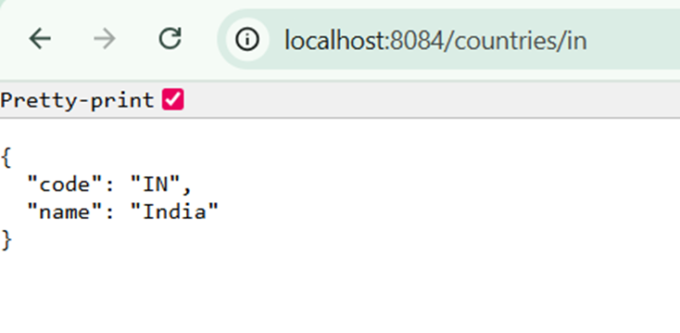

**6.Create authentication service that returns JWT**

**CODE;**

**AUTHENTICATIONCONTROLLER.JAVA**

package com.cognizant.spring_learn.controller;

import org.springframework.http.HttpHeaders;

import org.springframework.http.HttpStatus;

import org.springframework.http.ResponseEntity;

import org.springframework.web.bind.annotation.*;

import java.util.Base64;

import jakarta.servlet.http.HttpServletRequest;

@RestController

public class AuthenticationController {

@GetMapping("/authenticate")

public ResponseEntity<?> authenticate(HttpServletRequest request) {

String authHeader = request.getHeader(HttpHeaders.*AUTHORIZATION*);

if (authHeader == null || !authHeader.startsWith("Basic ")) {

return ResponseEntity.*status*(HttpStatus.*UNAUTHORIZED*).body("Unauthorized");

}

// Decode credentials

String base64Credentials = authHeader.substring("Basic ".length());

byte[] decodedBytes = Base64.*getDecoder*().decode(base64Credentials);

String credentials = new String(decodedBytes);

String[] values = credentials.split(":", 2);

String username = values[0];

String password = values[1];

if ("user".equals(username) && "pwd".equals(password)) {

return ResponseEntity.*ok*().body("{\"token\":\"dummy-token-for-user\"}");

} else {

return ResponseEntity.*status*(HttpStatus.*UNAUTHORIZED*).body("Unauthorized");

}

}

}

**SECURITYCONFIG.JAVA**

package com.cognizant.spring_learn.config;

import org.springframework.context.annotation.Bean;

import org.springframework.context.annotation.Configuration;

import org.springframework.security.config.annotation.web.configuration.EnableWebSecurity;

import org.springframework.security.web.SecurityFilterChain;

import org.springframework.security.config.annotation.web.builders.HttpSecurity;

@Configuration

@EnableWebSecurity

public class SecurityConfig {

@Bean

public SecurityFilterChain filterChain(HttpSecurity http) throws Exception {

http

.csrf(csrf -> csrf.disable()) // disable CSRF for simplicity

.authorizeHttpRequests(authz -> authz

.requestMatchers("/authenticate").permitAll() // allow /authenticate without auth

.anyRequest().authenticated()

)

.httpBasic(); // enable HTTP Basic auth

return http.build();

}

}

**APPLICATION.PROPERTIES**

spring.application.name=spring-learn

server.port=8090

logging.level.com.cognizant=DEBUG

logging.level.root=DEBUG

**SPRINGLEARNAPPLICATION.JAVA**

package com.cognizant.spring_learn;

import org.springframework.boot.SpringApplication;

import org.springframework.boot.autoconfigure.SpringBootApplication;

@SpringBootApplication

public class SpringLearnApplication {

public static void main(String[] args) {

SpringApplication.*run*(SpringLearnApplication.class, args);

}

}

**OUPUT:**

{"token":"dummy-token-for-user"}